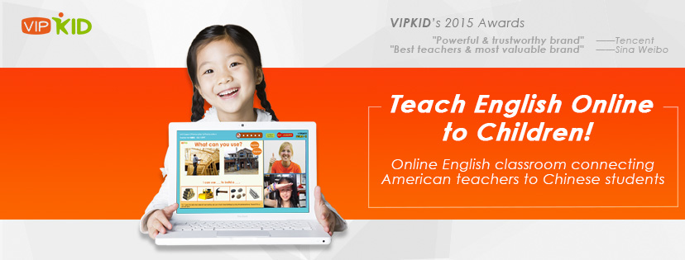

**Part-Time Online ESL Teacher for Children**

**Pay: $14 - $22 / hour**

VIPKID is currently looking for independent contractors as ESL teachers for our young students. We look for teachers that are energetic and can provide engaging classes, and who are motivated and excited to work with a promising company that is growing at a fast pace in China. VIPKID currently has 60,000+ active students and 6,000+ active teachers.

Founded in 2013, VIPKID's mission is to provide the American elementary school experience to Chinese children—all from the comfort of their homes.

Because of its innovative business model, platform and curriculum, VIPKID has won awards, such as the Shengjing Top 21 Global Innovation Award in 2015, the US-China Entrepreneurship Leader Award in 2014,  Sina’s China’s Most Valuable Online education brand and best teachers award in 2015, and Tencent's China's Most powerful education brand in 2015. VIPKID is also the official ETS partner providing the TOEFL Primary assessment.

VIPKID is also venture backed by top investors, such as Innovation Works, Sequoia Capital, Matrix Partners, H Capital, Northern Light Venture, Yunfeng Capital, Learn Capital, and Bryant Stibel.

**WHAT WE DO**

- 1-on-1 online full immersion English language and content classes

- Teach American curriculum, based on the Common Core State Standards

- 25-minute highly engaging lessons

**WHAT WE REQUIRE**

- Exposure to the American or Canadian K12 education system

- Teaching experience within ESL or K-12

- Bachelor’s degree

- Tech Requirements: Computer with Fast Internet connection and audio/video capability

**DETAILS**

**Contract type:** independent contractor  
**Contract term:** 6-Months   
**Start date:** Immediately  
**Hours:** Minimum 7.5 hours per week commitment. The 7.5 hours per week have to be during Beijing peak hours. Peak hours are Monday-Sunday 6-10pm, and Saturday-Sunday 9am-10pm in Beijing time. Teachers are not required to work full shifts, just to ensure 7.5 hours during the peak times.

**Here are the times converted to US times:**

|  |  |  |
| --- | --- | --- |
|  | **Peak Times** | |
|  | **Monday - Friday** | **Saturday - Sunday** |
| **US Times** | **Beijing 6pm - 10pm** | **Beijing 9am – 10pm** |
| **EST** | 6am - 10am | Fri-Sun 9pm – 10am |
| **CST** | 5am - 9am | Fri-Sun 8pm – 9am |
| **MST** | 4am - 8am | Fri-Sun 7pm – 8am |
| **PST** | 3am - 7am | Fri-Sun 6pm -7am |
| **Hawaii** | 1am - 5am | Fri-Sun 4pm – 5am |

**Payment:** Our teachers receive a minimum service fee rate of US$ 14-$18/hour. There are incentives for every lesson, so a typical service fee range would be between US$ 14-22/hour.

**HOW TO APPLY**

Please apply through our Teacher Recruitment Portal:

<http://teacher-recruitment.vipkid.com.cn/home.shtml?refereeId=1114706> .

Under “Recruitment Channel” please select “RP Alex Smith”.

**MORE INFORMATION**

Facebook: [www.facebook.com/VIPKID.com.cn](http://www.facebook.com/VIPKID.com.cn)    
Twitter: @TheVIPKIDLife  
Linkedin: <http://www.linkedin.com/company/vipkid>   
Youtube: <https://www.youtube.com/c/TeachVipkid>    
Reviews about us on Glassdoor: glassdoor.com/Overview/Working-at-VIPKID-EI_IE1105111.11,17.htm

If you have any further questions or would like to apply, please send your resume and any questions to [**macfarlane.envision@gmail.com**](mailto:macfarlane.envision@gmail.com)